Parts of the catalog/bibliographic record:

Part A) Main entry

Part B) Description
Area 1) Title and statement of responsibility
Area 2) Edition statement:
Area 3) Special area for Serials, maps etc.
Area 4) Publication information
Area 5) Physical description
Area 6) Series statement
Area 7) Notes
Area 8) Standard number

Part C) Subject access points

Part D) Additional author and title access points

Part E) Call no.

Part F) Search/Index words/terms

Part G) Location and other local information

Part H) Labels and other OPAC display information

Sample Online Catalog Result Screen: Parts of a Bibliographic Record
(ISBD Display)
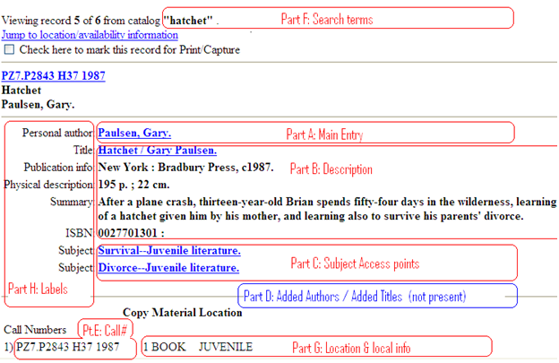
Sample Online Catalog Result Screen: Parts of a Bibliographic Record
(Destiny Display)

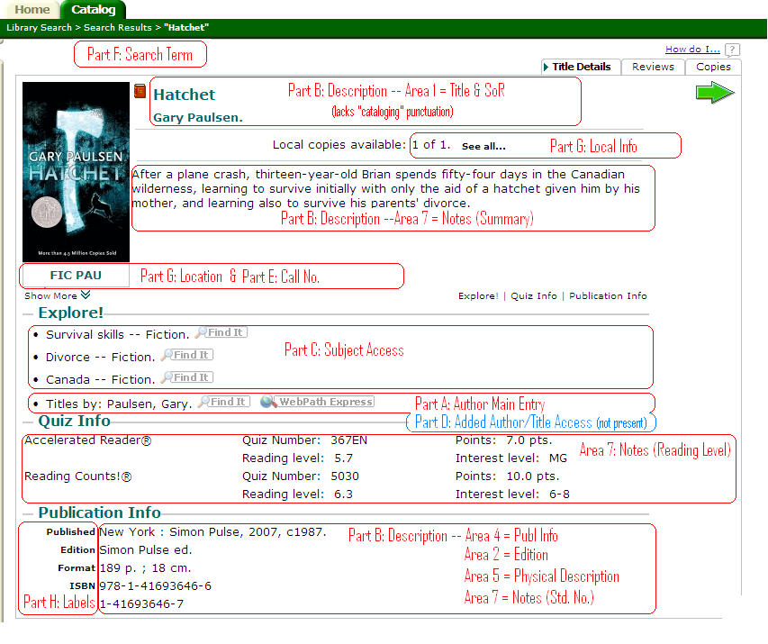

Sample Online Catalog Result Screen: Copy Information (Copies tab)
(Destiny Display)

